Web Mining Lab Assignment 4

Name: Om Ashish Mishra

Registration Number: 16BCE0789

Slot: F2

# The Question:

Write a python program to perform the following encoding for the ODD numbers between 1 – 30 i) Elias Gamma ii) Elias Delta iii) Golomb (b = 10)

# The Answer:

1. Urany Encoding:

**The Code:**

for i in range(1,30,2):

print("1"*i+"0")

**The Output:**

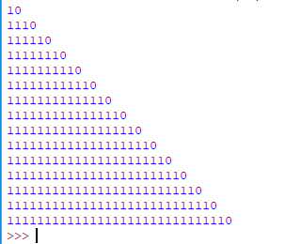

2. Elias Gamma Encoding:

**The Code:**

c=0

s=""

for i in range(1,30,2):

c=0

s=format(i,"b")

for j in range(len(s)):

c=c+1

s1 = "0"*(c-1)+s

print(s1)

s1=0

**The Output:**

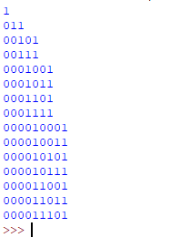

3. Elias Delta Encoding:

**The Code:**

import math

count=0

k1=0;

s2=""

s1=""

s=""

c=0

for i in range(1,30,2):

a = math.log2(i)

b = math.floor(a)

c = b+1

d = format(c,"b")

count=0

for j in range(len(d)):

count=count+1

s1 = "0"*(count-1)+d

f = format(i,"b")

g = f[1:]

s3 = s1+g

print(s3+"\n")

**The Output:**

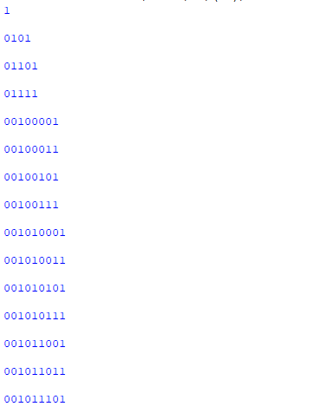

4. Golumb Encoding:

**The Code:**

import math

b = 10

for i in range(1,30,2):

a = math.log2(i)

b1 = math.floor(a)

c = math.pow(2,b1)-b

q = i//b

r = i%b

n = "1"*q + "0"

if(r<5):

x = format(r,"b")

if (len(x)!= 3):

x = "0"*(len(x)-1)+x

else:

x = x

print(n+x)

else:

x = b+r

y = format(x,"b")

print(n+y)

**The Output:**

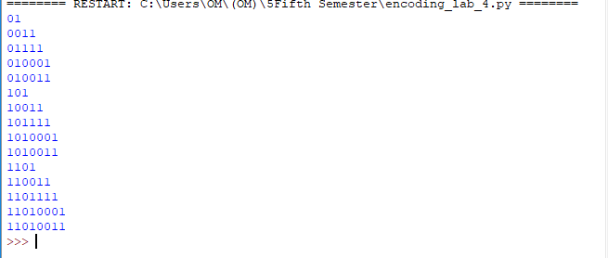

5. Variable Byte Coding:

**The Code:**

for i in range(1,30,2):

a = format(i,"b")

c = len(a)

if c < 7:

c = "0"*(7-c)+a

print(c+"0"+"\n")

else:

b = c[:-7]

print(b+"0"+"\n")

e = c[0:8]

print(e+"1\n")

**The Output:**

